Task 2: Superstore Case Study - Data Mining (“WH questions”)

What is Data Mining ?
Data mining is the process of extracting hidden patterns to reveal who is buying what, where and when it happens, ultimately explaining why these trends occur to guide smarter business decisions.

Dashboard snip shot covering WHAT, WHEN, WHO
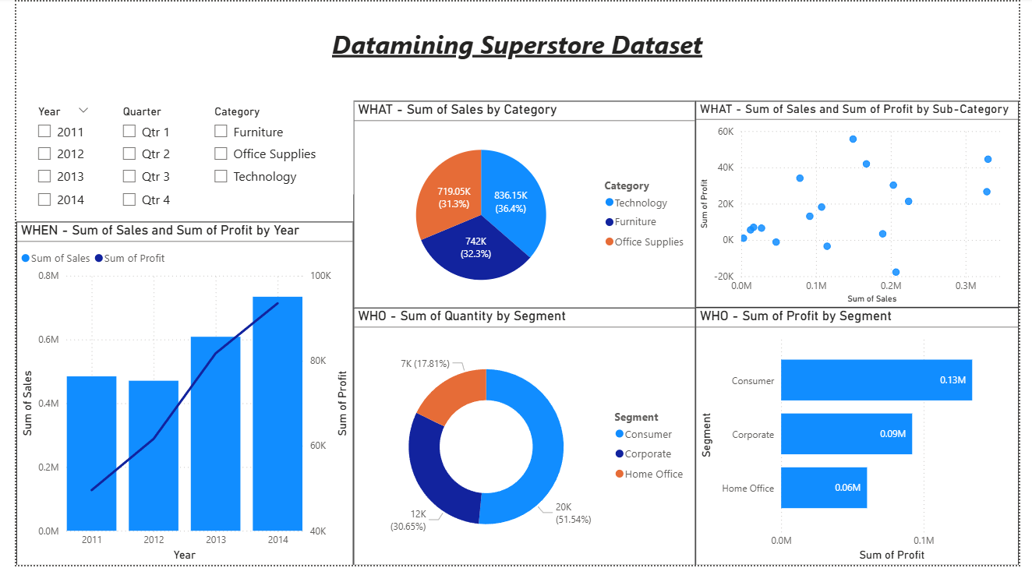

WHAT -
What Products and Categories contribute most to sales and profit?
Answer -
The charts show what products and categories contribute most to overall sales and profit, helping businesses focus on high-performing areas and identify underperforming ones.

WHO -
Who are the major contributors to revenue and profit?
Answer -
Customer segments are analyzed to identify who contributes the most in terms of quantity purchased and profit, enabling targeted marketing and customer-focused strategies.

WHEN -
When did business performance improve the most?
Answer -
Time-based analysis helps identify trends over years or quarters, showing when growth happens and supporting better planning and forecasting.

Dashboard snip shot covering WHERE, WHY
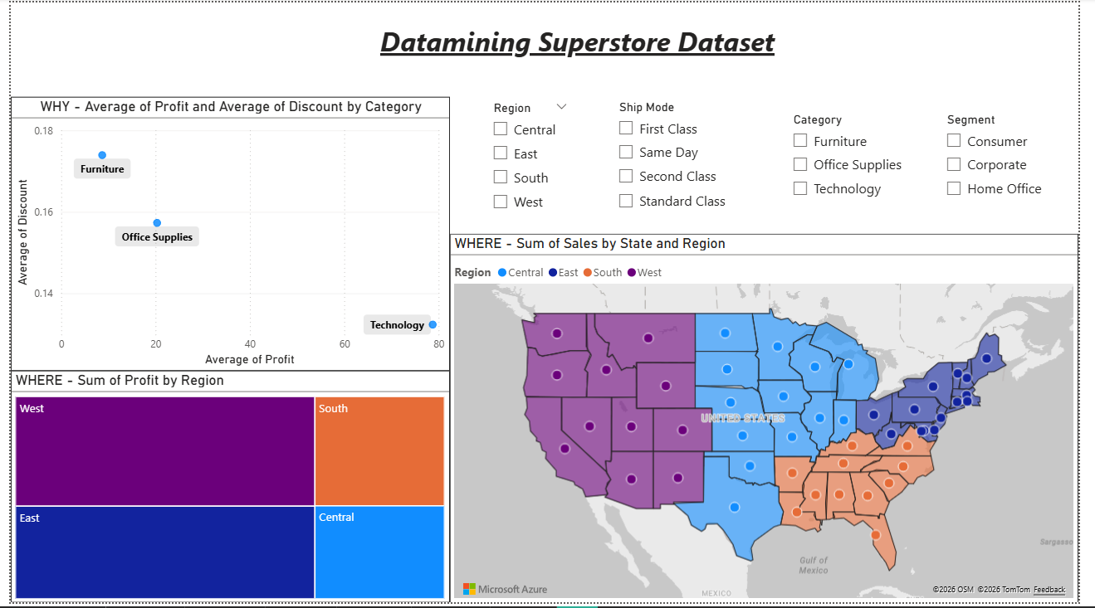
WHERE -
Where are the highest sales and profits generated?
Answer -
Regional and state-level analysis highlights where sales and profits are strongest, helping businesses allocate resources and expand in high-performing locations.

WHY -
Why do profits vary across product categories?
Answer -
This analysis helps identify why performance differs across categories, regions, and customer segments. By comparing profit, sales, and discounts, we can understand how pricing and customer behavior impact business outcomes.

Conclusion -
This data mining analysis helps identify profit drivers, customer behavior, regional performance, and time-based trends. The insights support better decision-making related to pricing, discount strategies, and regional focus.

